SAMPLE MARYLAND SPONSOR LETTER

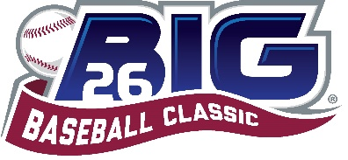

Friends and family,

I’m excited to share with you that I’ve been selected to represent the state of Maryland in the 2022 Big 26 Baseball Classic. This high school baseball all-star event takes place in Harrisburg, PA this summer at FNB Field. Team Maryland will participate in a 3-game series against Pennsylvania. We’ll also have the opportunity to participate in the Buddy Program for special needs children, teens, and young adults. College coaches will be invited to this event as well. The dates are July 14-17.
Would you consider sponsoring my participation in this event through a sponsorship? Sponsor donations help to offset the Player Participation fee, which covers things like player housing, meals, uniforms, facilities, and more.
Your sponsorship will be recognized in the Official Event Program on my Player Profile Page. (Sponsors may choose to remain anonymous in the Event Program.) Sponsorships can be made in any amount.
The online Sponsor Donation Form and complete details can be found at www.big26.com/fanclub-md. You’ll be able to select my name from a dropdown to ensure correct allocation. Sponsor support will be accepted until June 17th, 2022.
Thank you so much for your consideration! I’m excited to represent my state in the Big 26 Baseball Classic and I’d be honored to have your support! If you have any questions, please let me know.

